Best features to add onto our app:

From Timely:

* Visual Task Planning:

Explanation: This feature enables users to create a visual schedule. This gives users a concise breakdown of their day and promotes effective task planning.

Motivation:   
Enhanced User Engagement: A calendar format may be more user-friendly and interesting, particularly for those who are visually inclined.   
Better Time Management: Users can plan and prioritize work more strategically when they have a better understanding of how their time is spent thanks to visualization.

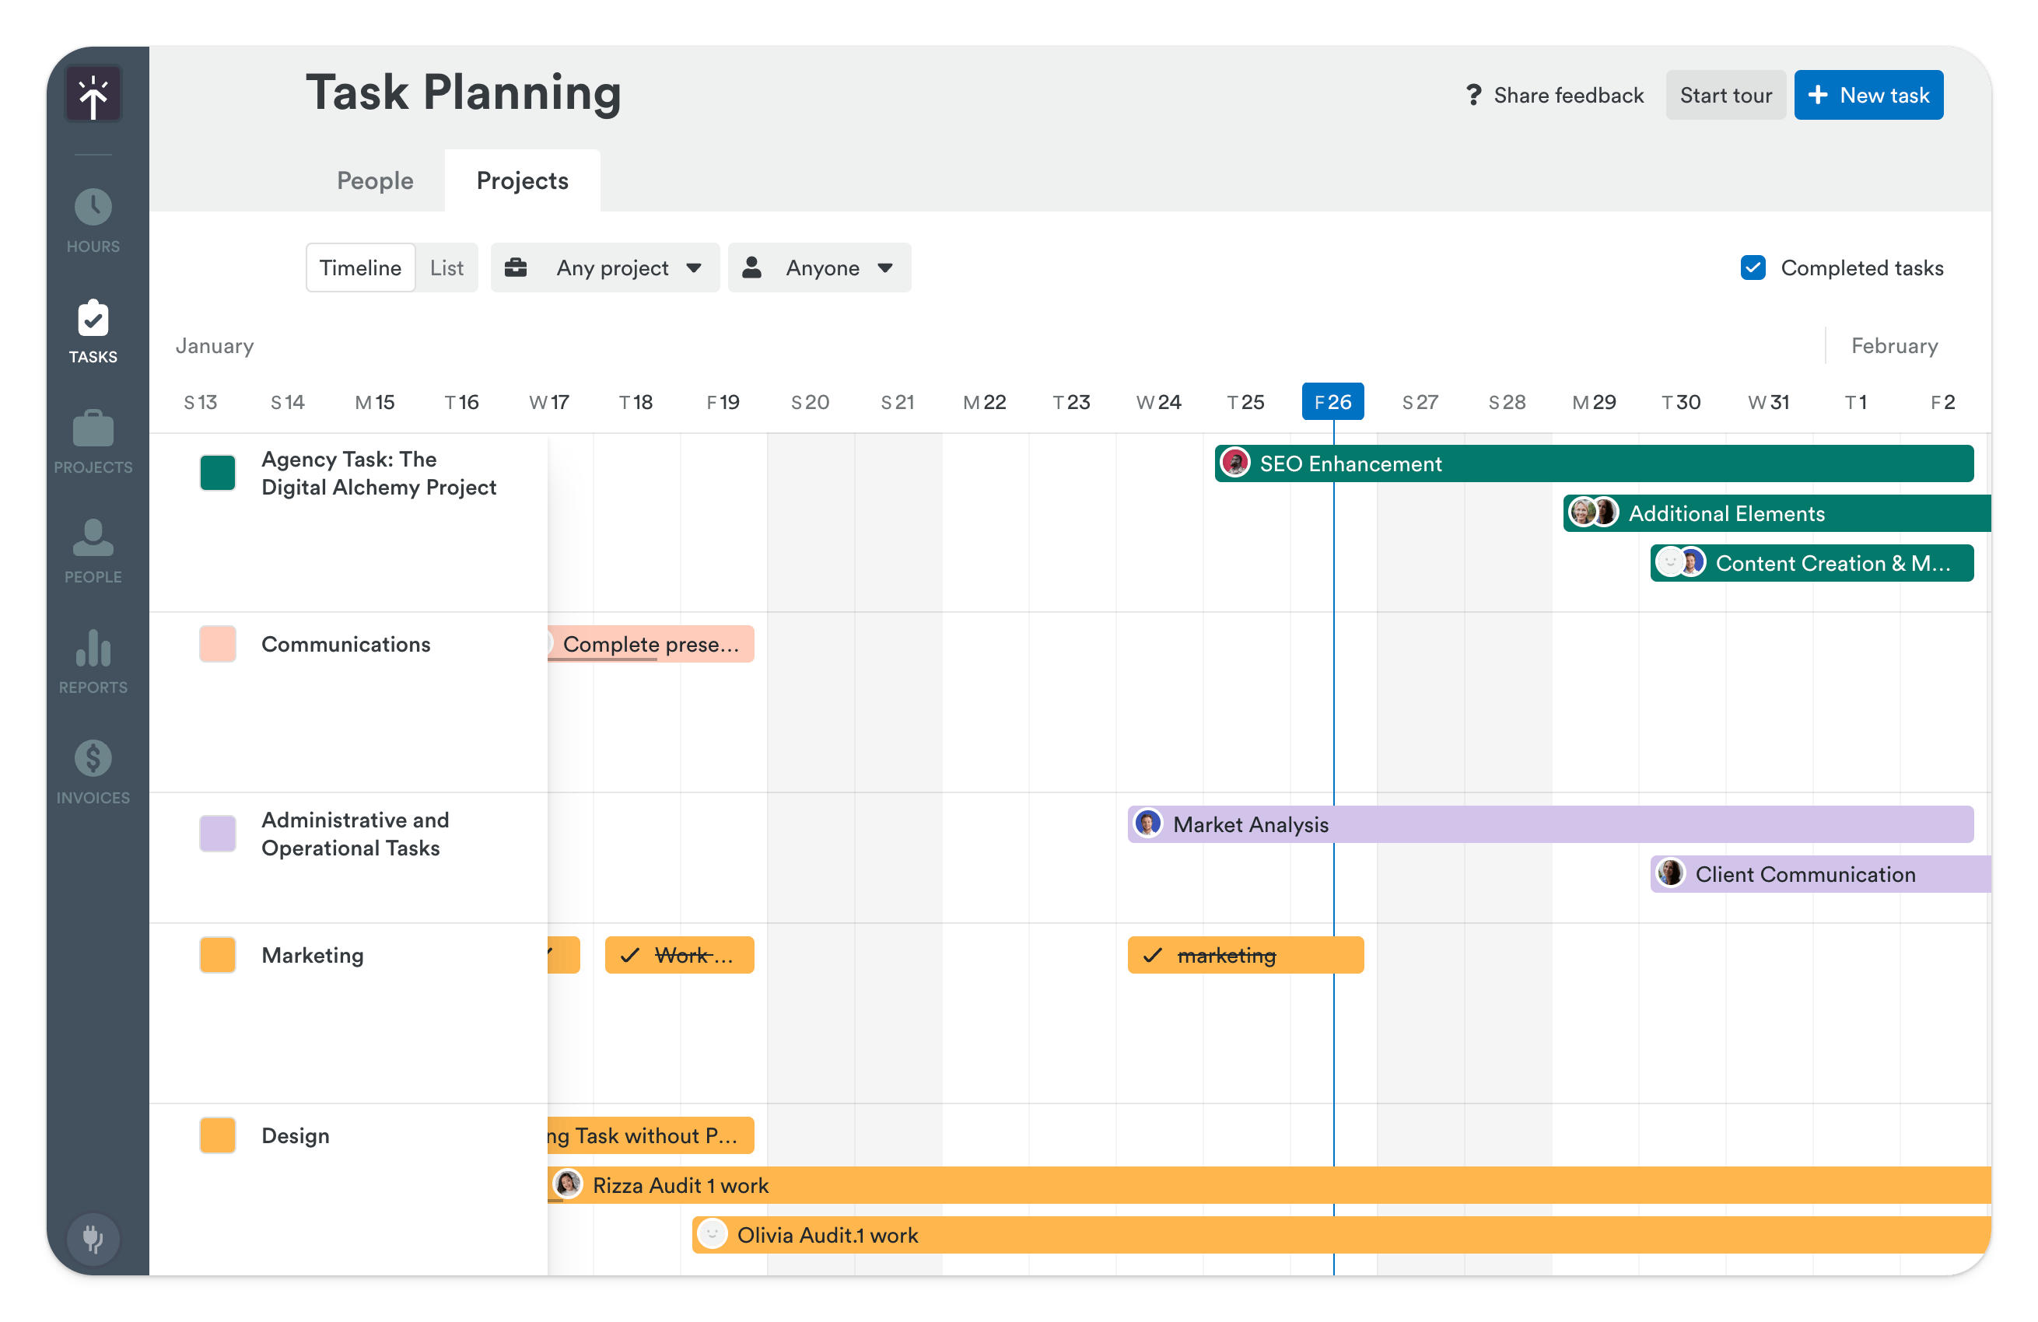

(Google, 2024)

* Automatic Time Tracking:

Explanation: This function uses the computer's activity to automatically track the amount of time spent on tasks, this lowers user effort and increases data accuracy.

Motivation:   
Decreased User Burden: By eliminating the requirement for users to remember to start and stop timers, human input and mistake risk are reduced.   
Increased Data Accuracy: Since automatic tracking removes the chance of forgetting to log time, the data is more trustworthy and suitable for analysis.

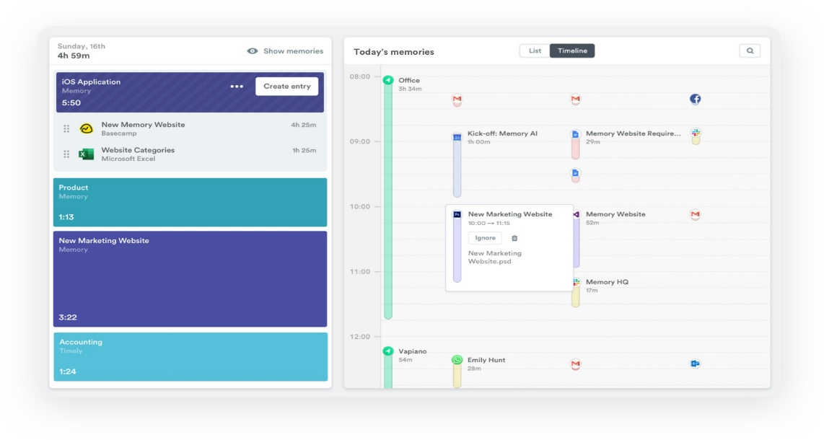

(Google, 2024)

* Idle detection:

explanation: This function recognizes idle times and subtracts them from the overall recorded duration. This makes it easier to discern between productive work time and distractions or breaks.   
  
Motivation:   
Encouragement of Focus: It serves as a reminder to users when they haven't been actively involved, which may lead them to reduce outside distractions and concentrate more on their task.   
  
Providing Accurate Data: Real work duration and production are better understood when idle time is excluded.

* Bulk editing:

The explanation for this feature is that it saves time and effort by enabling users to update or modify numerous time entries at once, as opposed to altering each one separately.

Motivation:

Enhanced Productivity: Editing several entries at once can help users save time and effort, particularly when doing repetitive tasks.   
Improved User Experience: For users who enter a lot of time, bulk editing makes the software more convenient and easier to use.

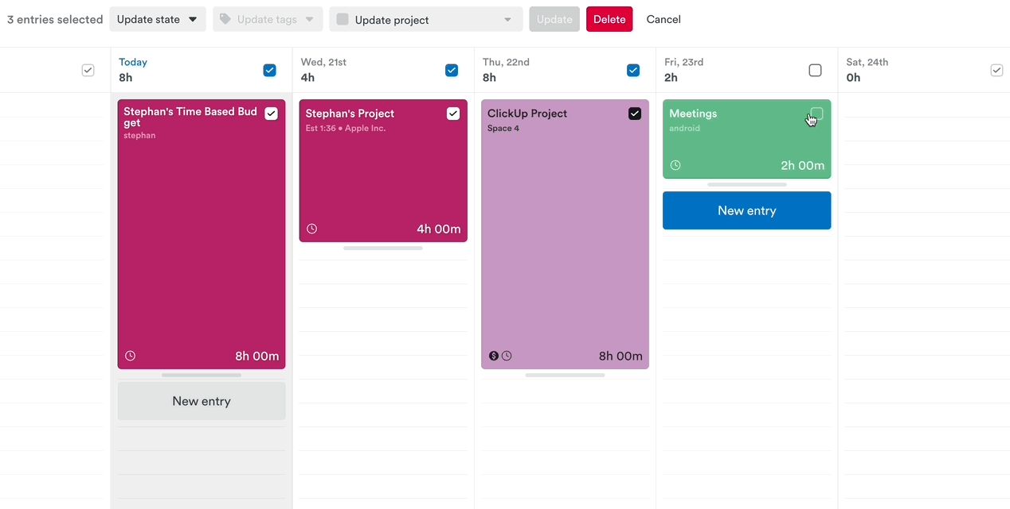 (Lisa, 2024)

(Timely, 2024)

From Toggl Track:

* Offline Tracking:

Explanation: This function lets users keep track of their time even when they're not online. The application saves the information locally and, when an internet connection is available, syncs it with the cloud.

Motivation:

Increased Flexibility: When tracking time when offline or in places with spotty internet access, users can be sure that their data is being collected.   
Enhanced Data Reliability: By utilizing offline monitoring, worries regarding data loss resulting from internet connectivity problems are removed.

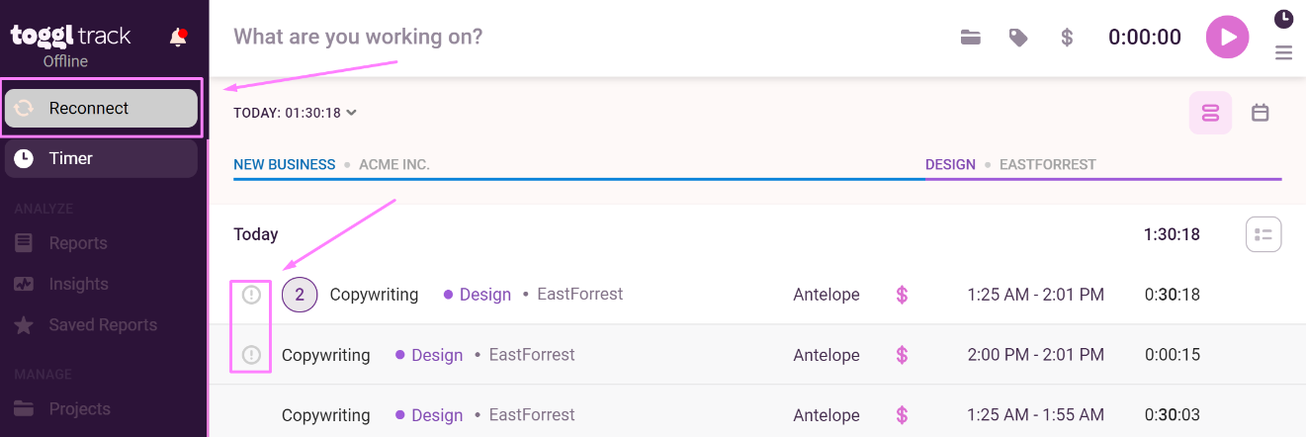 (Vedran, 2024)

* Free Plan with Basic Features:

Explanation: Toggl Track provides a free plan that includes basic reporting, project management, and time tracking, among other vital features. This enables customers to test out the app before signing up for a premium membership.   
Motivation:

Draws in New Users: Before purchasing a premium plan, a free tier enables users to test the software and see its value, this could eventually result in paying consumers.   
Expands your User Base A free plan can draw in more users and provide you with useful user feedback and data for future development.

(Toggl, 2024)

From Harvest:

* Simple and intuitive time tracking

Explanation: Harvest provides an easy-to-use time tracking interface.

People may:   
  
You may start and end timers right from within the app, desktop widget, or browser extension.   
Timesheets for tasks done outside of the app can be manually entered.   
For appropriate invoicing, distinguish between billable and non-billable hours.   
Sort monitored time according to client, task, and project.   
Motivation: By using an easy technique, time monitoring becomes consistent and reliable, producing useful data for project management as well as individual productivity.

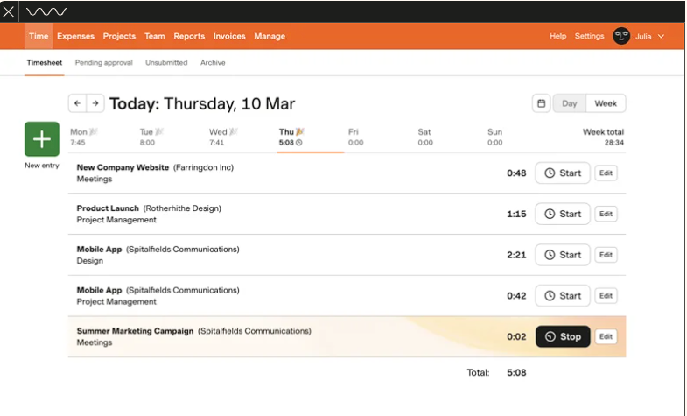

(Harvest, 2024)

(Harvest, 2024)

# References

Google, 2024. *Google.* [Online]   
Available at: https://www.google.com/url?sa=i&url=https%3A%2F%2Ftimelyapp.com%2Ffeature%2Ftasks&psig=AOvVaw0IFVQNaVZZWwXdEU62kVP5&ust=1710046743777000&source=images&cd=vfe&opi=89978449&ved=0CBMQjRxqFwoTCMi9nNqy5oQDFQAAAAAdAAAAABAP  
[Accessed 08 March 2024].

Google, 2024. *Google.* [Online]   
Available at: https://www.google.com/url?sa=i&url=https%3A%2F%2Ftimelyapp.com%2Fblog%2Fautomated-time-tracker&psig=AOvVaw2X1yYy1LnTmXssxJwc4yDC&ust=1710047033741000&source=images&cd=vfe&opi=89978449&ved=0CBMQjRxqFwoTCLjbs-2z5oQDFQAAAAAdAAAAABAI  
[Accessed 09 March 20244].

Harvest, 2024. *GetHarvest.* [Online]   
Available at: https://www.getharvest.com/features  
[Accessed 07 March 2024].

Harvest, 2024. *GetHarvest.* [Online]   
Available at: https://www.getharvest.com/features  
[Accessed 09 March 2024].

Hourstack, 2024. *Hourstack.* [Online]   
Available at: https://hourstack.com/features/reporting  
[Accessed 03 March 2024].

Lisa, 2024. *intercomcdn.* [Online]   
Available at: https://support.timelyapp.com/en/articles/5327208-bulk-actions-in-timely  
[Accessed 09 March 2024].

Timely, 2024. *Timely.* [Online]   
Available at: https://timelyapp.com/timely-features  
[Accessed 03 March 2024].

Toggl, 2024. *Toggl.* [Online]   
Available at: https://toggl.com/track/features/  
[Accessed 03 March 2024].

Vedran, 2024. *Support.toggl.* [Online]   
Available at: https://support.toggl.com/en/articles/2220695-can-toggl-track-work-offline  
[Accessed 09 March 2024].